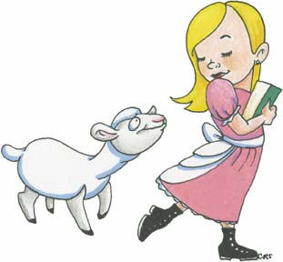  Mary had a little lamb  Long version: http://www.youtube.com/watch?v=DJ4Ie1XZS0c  Short version:  http://www.youtube.com/watch?v=u_K9hFxSvDM  Mary had a little lamb, little lamb, little lamb  Mary had a little lamb, its fleece was white as snow  Everywhere that Mary went, Mary went, Mary went  Now everywhere that Mary went, the lamb was sure to go,  It followed her to school one day, school one day, school one day,  It followed her to school one day, which was against the rules,  Made the children laugh and play, laugh and play, laugh and play,  Made the children laugh and play, to see the lamb at school,  And so the teacher turned it out, turned it out, turned it,  And so the teacher turned it out, but still it lingered near,  Why does the lamb love Mary so, love Mary so, love Mary so,  Why does the lamb love Mary so, the eager children cried,  Why Mary loves the lamb you know the lamb you know, the lamb you know,  Why Mary loves the lamb you know, the teacher did reply, | 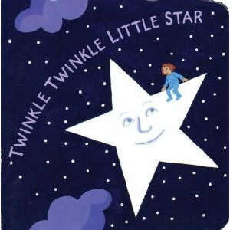  Twinkle Twinkle Little Star  Long version:  http://www.youtube.com/watch?v=LCQtrlFAyf4  Short version:  http://www.youtube.com/watch?v=yCjJyiqpAuU  Twinkle twinkle little star,  How I wonder what you are,  Up above the world so high,  Like a diamond in the sky,  Twinkle twinkle little star,  How I wonder what you are,  When the blazing sun is gone,  When he nothing shines upon,  Then you show your little light,  Twinkle, twinkle, all night long,  Twinkle twinkle little star,  How I wonder what you are,  Then the traveller in the dark,  Thanks you for your tiny spark,  He could not see which way to go,  If Twinkle you did not twinkle so,  Twinkle twinkle little star,  How I wonder what you are,  Twinkle twinkle little star,  How I wonder what you are,

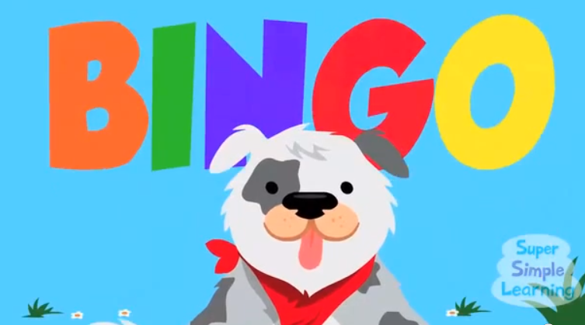  http://www.youtube.com/watch?v=9mmF8zOlh_g  There was a farm who had a dog,  And Bingo was his name o,  B I N G O, B I N G O,  B I N G O, and Bingo was his name o  There was a farm who had a dog,  And Bingo was his name o,  (clap) I N G O x3  And Bingo was his name o  There was a farm who had a dog,  And Bingo was his name o,  (pat leg) (pat legs) N G O x3  And Bingo was his name o  There was a farm who had a dog,  And Bingo was his name o,  (pat tummy) (pat tummy) (pat tummy) G O x3  And Bingo was his name o  There was a farm who had a dog,  And Bingo was his name o,  (tap head) (tap head) (tap head) (tap head) O x3  And Bingo was his name o  There was a farm who had a dog,  And Bingo was his name o,  (jump) (jump) (jump) (jump) (jump) x3  And Bingo was his name o  There was a farm who had a dog,  And Bingo was his name o,  B I N G O, B I N G O,  B I N G O, and Bingo was his name o | 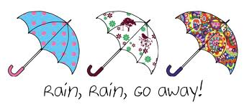  http://www.youtube.com/watch?v=Izq1E6b4WlQ  Rain Rain go away,  Come another day,  Daddy wants to play,  Rain Rain go away,  Rain Rain go away,  Come another day,  Mommy wants to play,  Rain Rain go away,  Rain Rain go away,  Come another day,  Brother wants to play,  Rain Rain go away,  Rain Rain go away,  Come another day,  Sister wants to play,  Rain Rain go away,  Rain Rain go away,  Come another day,  Baby wants to play,  Rain Rain go away,  Rain Rain go away,  Come another day,  All the family wants to play,  Rain Rain go away

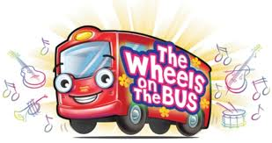  https://www.youtube.com/watch?v=ioYr3JF-hLI  The wheels on the bus go round and round, round and round, round and round.  The wheels on the bus goes round and round all through the town.  The horn on the bus goes beep beep beep, beep beep beep, beep beep, beep.  The horn on the bus goes beep beep beep all through the town.  The wipers on the bus go swish swish swish, swish swish swish, swish swish swish.  The wipers on the bus goes swish swish swish all through the town.  The people on the bus go chatter chatter chatter, chatter chatter chatter,  chatter chatter chatter.  The people on the bus goes chatter chatter chatter all through the town.  The babies on the bus goes wah wah wah, wah wah wah, wah wah wah.  The baby on the bus goes wah wah wah, all through the town.  The bell on the bus goes ding ding ding, ding ding ding, ding ding ding.  The bell on the bus goes ding ding ding, all through the town.  The doors on the bus go open and shut, open and shut, open and shut.  The doors on the bus go open and shut, all through the town.  The wheels on the bus go round and round, round and round, round and round  The wheels on the bus go round and round, all through the town. | Humpty Dumpty  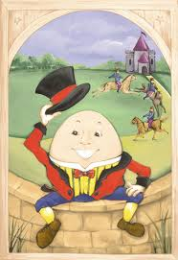  http://www.youtube.com/watch?v=IbjM6M7AHII  Humpty Dumpty Lyrics:  Humpty Dumpty sat on a wall,  Humpty Dumpty had a great fall,  All the king's horses and all the king's men,  Couldn't put Humpty together again.
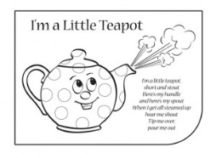

http://www.youtube.com/watch?v=_dlozKGibvk
I’m a little teapot
I'm a little teapot
Short and stout
Here is my handle
And here is my spout
When the tea is ready
Hear me shout
Just tip me over and pour me out
I'm a little teapot
Short and stout
Here is my handle
Here is my spout
When I get all steamed up
Hear me shout
Just tip me over and pour me out
I'm a little teapot
Short and stout
Here is my handle
And here is my spout
When the tea is ready
Hear me shout
Just tip me over and pour me out

Other songs:
Itsy bitsy spider http://www.youtube.com/watch?v=ZFuOrPaDrA8
Pat-a-cake http://www.youtube.com/watch?v=5bCtjSg2ijI
Ten green bottles http://www.youtube.com/watch?v=T0ooQv7oHvw
Baa Baa Black Sheep http://www.youtube.com/watch?v=BhM1VRzXLII

Grammar: Would
See week 10
Activity: ‘What’s in the box?’

Grammar: Adverbs
See Week 11

Books and Reading
Please bring any books you use to read with the children to the class on Thursday.
Tips for reading aloud:
- Scan for any unknown words first and find out their meaning
- Make sure you are familiar with the text
- Take your time, it is not a race, you are trying to get the meaning across
- Enjoy the story and be expressive!

Go, Dog, Go, by P.D. Eastman (Slide show of book)
http://www.slideshare.net/brian99/teach-kids-english-with-go-dogs-go

The Very Hungry Caterpillar by Eric Cerle (Slide show of book)
http://www.slideshare.net/gabner/the-very-hungry-caterpillar-presentation-691778

Where the Wild Things Are by Maurice Sendak
http://www.youtube.com/watch?v=2bptuYPvfgk (Video of book being read)

Activity 3: Writing your own stories
Important fairy tale phrases:
Once upon a time…
Prince Princess dragon fairy
Good evil magic witch
Cast a spell knight giant frog
Castle sword tower brave
…And they all lived happily ever after

Famous fairy tales:
Snow white and the seven dwarfs Beauty and the Beast
Rapunzel Sleeping Beauty
Cinderella Rumpelstiltskin
Little Red Riding Hood Hansel and Gretel
Goldilocks and the three Bears Jack and the Bean Stalk
Aladdin Puss in Boots

Tips for writing your own story:
- Have a beginning, middle and end.
- Do a plan of the story before you start
- Use descriptions: this means adjectives and adverbs
- Always start writing in English, do NOT write it in Spanish and then try and translate
- Get the children to illustrate their stories
Activity: Consequences
Activity: Write in your own dialogue in the cartoon.
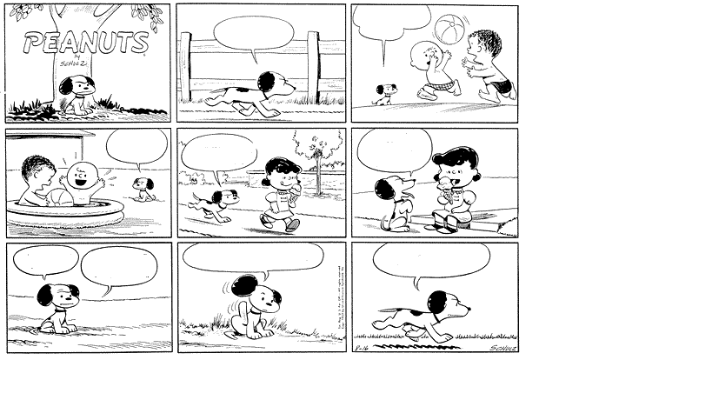

Here is a famous story to get you going:
“Hop on Pop” by Dr. Seuss
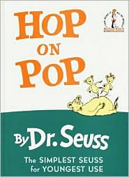  UP PUP Pup is up.  CUP PUP Pup in cup.  PUP CUP Cup on pup.  MOUSE HOUSE Mouse on house.  HOUSE MOUSE House on mouse.  ALL TALL We all are tall.  ALL SMALL We all are small.  ALL BALL We all play ball.  BALL WALL Up on a wall.  ALL FALL Fall off the wall.  DAY PLAY We play all day.  NIGHT FIGHT We fight all night.  HE ME He is after me.  HIM JIM Jim is after him.  SEE BEE We see a bee.  SEE BEE THREE Now we see three.  THREE TREE Three fish in a tree.  Fish in a tree? How can that be?  RED RED They call me Red.  RED BED I am in bed.  RED NED TED and ED in BED  PAT PAT they call him Pat.  PAT SAT Pat sat on hat.  PAT CAT Pat sat on cat.  PAT BAT Pat sat on bat.  NO PAT NO Don’t sit on that.  SAD DAD BAD HAD Dad is sad.  Very, very sad.  He had a bad day. What a day Dad had!  THING THING What is that thing?  THING SING That thing can sing!  SONG LONG A long, long song.  Good-by, Thing. You sing too long. | WALK WALK We like to walk.  WALK TALK We like to talk.  HOP POP We like to hop.  We like to hop on top of Pop.  STOP You must not hop on Pop.  Mr. BROWN Mrs. BROWN  Mr. Brown upside down.  Pup up. Brown down.  Pup is down. Where is Brown?  WHERE IS BROWN? THERE IS BROWN!  Mr. Brown is out of town.  BACK BLACK Brown came back.  Brown came back with Mr. Black.  SNACK SNACK Eat a snack.  Eat a snack with Brown and Black.  JUMP BUMP He jumped. He bumped.  FAST PAST He went past fast.  WENT TENT SENT He went into the tent.  I sent him out of the tent.  WET GET Two dogs get wet.  HELP YELP They yelp for help.  HILL WILL Will went up hill.  WILL HILL STILL Will is up hill still.  FATHER MOTHER SISTER BROTHER  That one is my other brother.  My brothers read a little bit.  Little words like If and it.  My father can read big words, too.  Like CONSTANTINOPLE and TIMBUKTU  SAY SAY What does this say?  seehemewepatpup pop  hethreetreebee  tophopstop  Ask me tomorrow but not today.

