Week 14 - August 20 and 22, 2013

Common Phrasal Verbs with GET

- Get along (with) -To have a good relationship with
- Get back (from) – 1) return from somewhere 2) receive again
- Get in, get into – 1) enter a car 2) arrive
- Get off - Leave any vehicle
- Get on - Enter any vehicle (except car)
- Get out of – 1) leave a car 2) avoid some unpleasant activity
- Get over – 1) Recover from an illness 2) not be bothered by something/someone anymore
- Get through- finish
- Get up - Arise from bed, a chair etc.

Get Well Soon Song

You´re my best friend, best friend
Friend you are the best
And you´re just not feeling well
Get some rest today
So tomorrow we can play
I want my best friend to get well.

Read a book, take a nap,
Eat a fruity, juicy snack,
Write a letter, draw a picture,
It´s your day to just relax.
(Repeat 3 times)

Get Funky (Dance song) (starts at 1:20)
(To play with their kids, more about following instructions than singing, show directions)
Can you hear me? Yeah! Can you hear me now? Uh-huh!
Everybody please stand up, because it´s time to get funky. Get in Line.
Get funky do the monkey, get clappy, get happy!
Step to the right and shake,
Step to the left and snake,
Step backwards, step forwards,
Now jump, jump again,
Get funky, do the monkey, get clappy, get happy!
Slide to the right, real smooth,
Slide to the left, in the groove,
Right foot stomp, stomp two times,
Left foot stomp, stomp two times,
Get funky, do the monkey, get clappy, get happy!
Jump, jump two times, jump, jump two times,
Now reach, and sway, and shake it your way,
Get funky, do the monkey, get clappy, get happy!
Can you hear me? Yeah! Can you hear me now? Uh-huh!(4 times)
Get funky, do the monkey, get clappy, get happy!
Take two steps to the right and shimmy,
Take two steps to the left, now gimme
Backstroke, uh-huh, Now jump, jump two times
Get funky, do the monkey, get clappy, get happy!
Jump two times, right foot stomp,
Jump three times, left foot stomp,
Jump, jump two times, jump, Now freeze!
Get funky, do the monkey, get clappy, get happy!
Reach, now touch the floor, twist, do you want some more?
Get funky, do the monkey, get clappy, get happy!
Can you hear me? Yeah! Can you hear me now? Uh-huh! (Repeat 4 times)

Tall Short Sleepy Happy Patient Impatient Nervous Angry Fat Thin Bored Old Young
Marcia Herbert Jeremy John Lana Billy Sam Michelle George
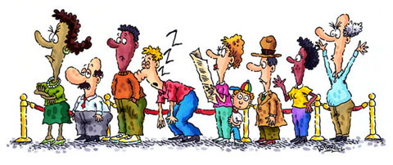

Thursday, August 22

Forming Comparative and Superlative Adjectives

One-syllable adjectives- Form the comparative and superlative forms of a one-syllable adjective by adding –er for the comparative form and –est for the superlative.
One-Syllable Adjective | Comparative Form | Superlative Form
tall | taller | tallest
old | older | oldest
long | longer | longest
- Mary is taller than Max.
- Mary is the tallest of all the students.
If the one-syllable adjective ends with an e, just add –r for the comparative form and –st for the superlative form.
One-Syllable Adjective with Final -e | Comparative Form | Superlative Form
large | larger | largest
wise | wiser | wisest
- Mary's car is larger than Max's car.
- Mary's house is the tallest of all the houses on the block.
If the one-syllable adjective ends with a single consonant with a vowel before it, double the consonant and add –er for the comparative form; and double the consonant and add –est for the superlative form.
One-Syllable Adjective Ending with a Single Consonant with a Single Vowel before It | Comparative Form | Superlative Form
big | bigger | biggest
thin | thinner | thinnest
fat | fatter | fattest
- My dog is bigger than your dog.
- My dog is the biggest of all the dogs in the neighborhood.

Two-syllable adjectives- With most two-syllable adjectives, you form the comparative with more and the superlative with most.
Two-Syllable Adjective | Comparative Form | Superlative Form
peaceful | more peaceful | most peaceful
pleasant | more pleasant | most pleasant
careful | more careful | most careful
thoughtful | more thoughtful | most thoughtful
- Jill is more thoughtful than your sister.
- Mary is the most thoughtful person I've ever met.

If the two-syllable adjectives ends with –y, change the y to i and add –er for the comparative form. For the superlative form change the y to i and add –est.
Two-Syllable Adjective Ending with -y | Comparative Form | Superlative Form
happy | happier | happiest
angry | angrier | angriest
busy | busier | busiest
- John is happier today than he was yesterday.
- John is the happiest boy in the world.
Two-syllable adjectives ending in –er, -le, or –ow take –er and –est to form the comparative and superlative forms.
Two-Syllable Adjective Ending with -er, -le, or -ow | Comparative Form | Superlative Form
narrow | narrower | narrowest
gentle | gentler | gentlest
- The roads in this town are narrower than the roads in the city.
- This road is the narrowest of all the roads in California.

Adjectives with three or more syllables - For adjectives with three syllables or more, you form the comparative with more and the superlative with most.
Adjective with Three or More Syllables | Comparative Form | Superlative Form
generous | more generous | most generous
important | more important | most important
intelligent | more intelligent | most intelligent
- John is more generous than Jack.
- John is the most generous of all the people I know.

Exceptions - Irregular adjectives.
Irregular Adjective | Comparative Form | Superlative Form
good | better | best
bad | worse | worst
far | farther | farthest
little | less | least
many | more | most
- Italian food is better than American food.
- My dog is the best dog in the world.
- My mother's cooking is worse than your mother's cooking.
- Of all the students in the class, Max is the worst.
Two-syllable adjectives that follow two rules. These adjectives can be used with -er and -est and with more and most.
Two-Syllable Adjective | Comparative Form | Superlative Form
clever | cleverer | cleverest
clever | more clever | most clever
gentle | gentler | gentlest
gentle | more gentle | most gentle
friendly | friendlier | friendliest
friendly | more friendly | most friendly
quiet | quieter | quietest
quiet | more quiet | most quiet
simple | simpler | simplest
simple | more simple | most simple
- Big dogs are gentler than small dogs.
- Of all the dogs in the world, English Mastiffs are the gentlest.
- Big dogs are more gentle than small dogs.
- Of all the dogs in the world, English Mastiffs are the most gentle.

Compare the following people: 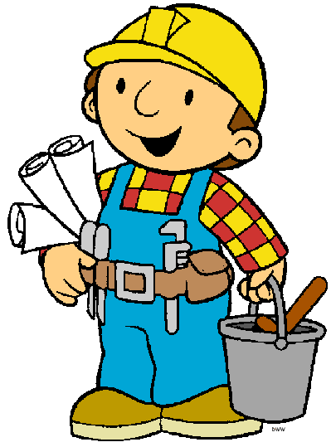 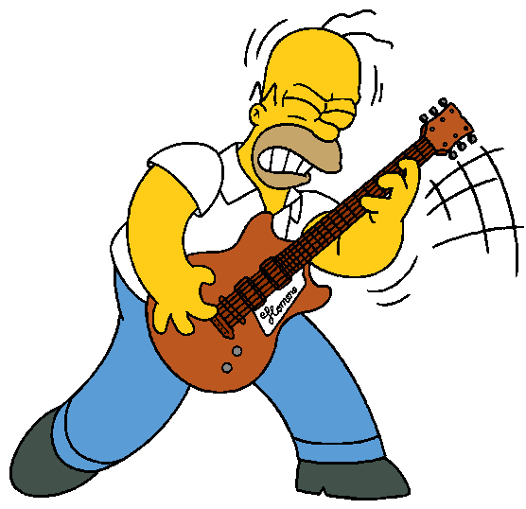 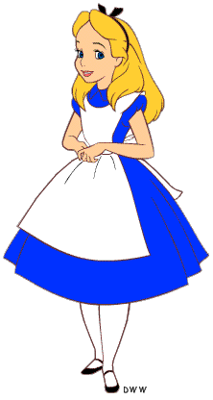
Bob Homer Alice
28 years old 39 years old 9 years old
55 kilos 80 kilos 33 kilos
1.50 mt 1.55 mt 1.20 mt
Bob is ___________(YOUNG) than Homer.
Homer is ______________ (OLD) than Alice.
Alice is _____________ (SLIM) than Bob.
Bob is ___________ (SHORT) than Homer.
Homer is _____________ (FAT) than Bob.
Alice is ____________ (SHORT) than Homer.
Homer is _______________ (UGLY) than Alice.
Homer is ____________ (SLOW) than Bob.
Bob is ___________ (TIDY) than Homer.
Alice is __________ (BEAUTIFUL) than Bob.
Alice has got ___________ (LONG) hair than Bob.
Homer can play the guitar ___________ (GOOD) than Alice.
Alice can run ____________ (FAST) than Homer.
Alice draws _____________ (BAD) than Bob.
Bob is __________________ (INTELLIGENT) than Homer.
Homer is a ______________ (INTERESTING) person than Bob.
Now, compare the following people: 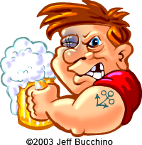 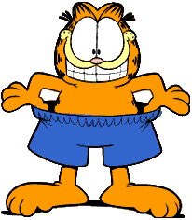 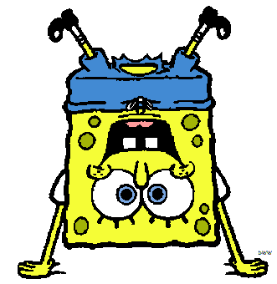
Harry Garfield Sponge Bob
32 years old 10 years old 6 years old
75 kilos 60 kilos 3 kilos
1.90 mt 0.57 mt 0.20 mt
ex: Harry is older than Garfield. (OLD-YOUNG)
Write ONE word per gap
Garfield _________________Sponge Bob. (YOUNG-OLD)
Sponge Bob ___________________________Harry. (FAT-SLIM)
Harry __________________________Sponge Bob. (SHORT-TALL)
Garfield ________________________ Harry. (SHORT-TALL)
Garfield _________________________ Harry. (FUNNY-BORING)
Sponge Bob's eyes _____________________ Harry's. (SMALL-BIG)
Harry ________________________ Garfield. (STRONG-WEAK)
Garfield _________________________ Harry. (BEAUTIFUL-HORRIBLE)
Bob Sponge _____________ at sports ________ Garfield. (GOOD-BAD)

Record Breakers
It may be the smallest, it may be the tallest, it may be the fastest that there has ever been. The highest, the deepest, the road that´s the steepest, the longest and widest the world has ever seen.
There are many kinds of records, serious or odd. Running, jumping, lifting weights or catching fish like cod. If you can think of something new and put it to the test, maybe you could be the one who´s better than the rest. (Repeat chorus)
If you sit inside a bath up to your neck in beans, or walk about with seven people all inside your jeans. Stand up on the highest pair of stilts and run a mile, or on your face for two whole weeks you always wear a smile. (Repeat chorus)
I think my sister holds the record talking on the phone. I think I´ll go and beat the time around the world alone. I could cycle, ride a horse, or do it on my hands. Maybe there´s a record for stretching rubber bands. (Repeat chorus)

1. Kelly Clarkson – Stronger
What doesn’t kill you makes you ___________
Stand a little _______________
Doesn’t mean I’m lonely when I’m alone
What doesn’t kill you makes you a fighter
Footsteps even ___________
Doesn’t mean I’m over cause you’re gone
What doesn’t kill you makes you _____________

2. Cristina Aguilera – Fighter
So I wanna say thank you
‘Cause it
Makes me that ________________________
Makes me work _________________________ Makes me that ______________________
So thanks for making me a fighter
Made me learn ___________________
Made my skin __________________________ Makes me that much ________________
So thanks for making me a fighter

3. Kanye West – Stronger
N-na-now th-that that don’t kill me
Can only make me ________________
I need you to hurry up now
Cause I can’t wait ________________
I know I got to be right now
Cause I can’t get much ______________
Man, I’ve been waiting all night now
That’s how long I’ve been on ya

4. Justin Bieber – Never Say Never
Now he’s ____________ than me
____________than me
He’s ___________ than me, __________than me
And his arms are a little bit ____________ than me
But he ain’t on a jb song with me.

5. The Corrs – Would You Be Happier?
Would you be ___________ if you were someone together?
Would the sun shine ___________ if you played a ____________ part?
Would you be wonderful if it wasn’t for the weather?
You’re gonna be just fine (gonna be just fine)

6. India Arie – Beautiful Flower
‘Cause you’re beautiful like a flower
_____________________ a diamond
You are powerful like a fire
You will heal the world with your mind
There is nothing in the world that you cannot do
When you believe in you

