**Week 9: Adjectives, opposites and creative writing**

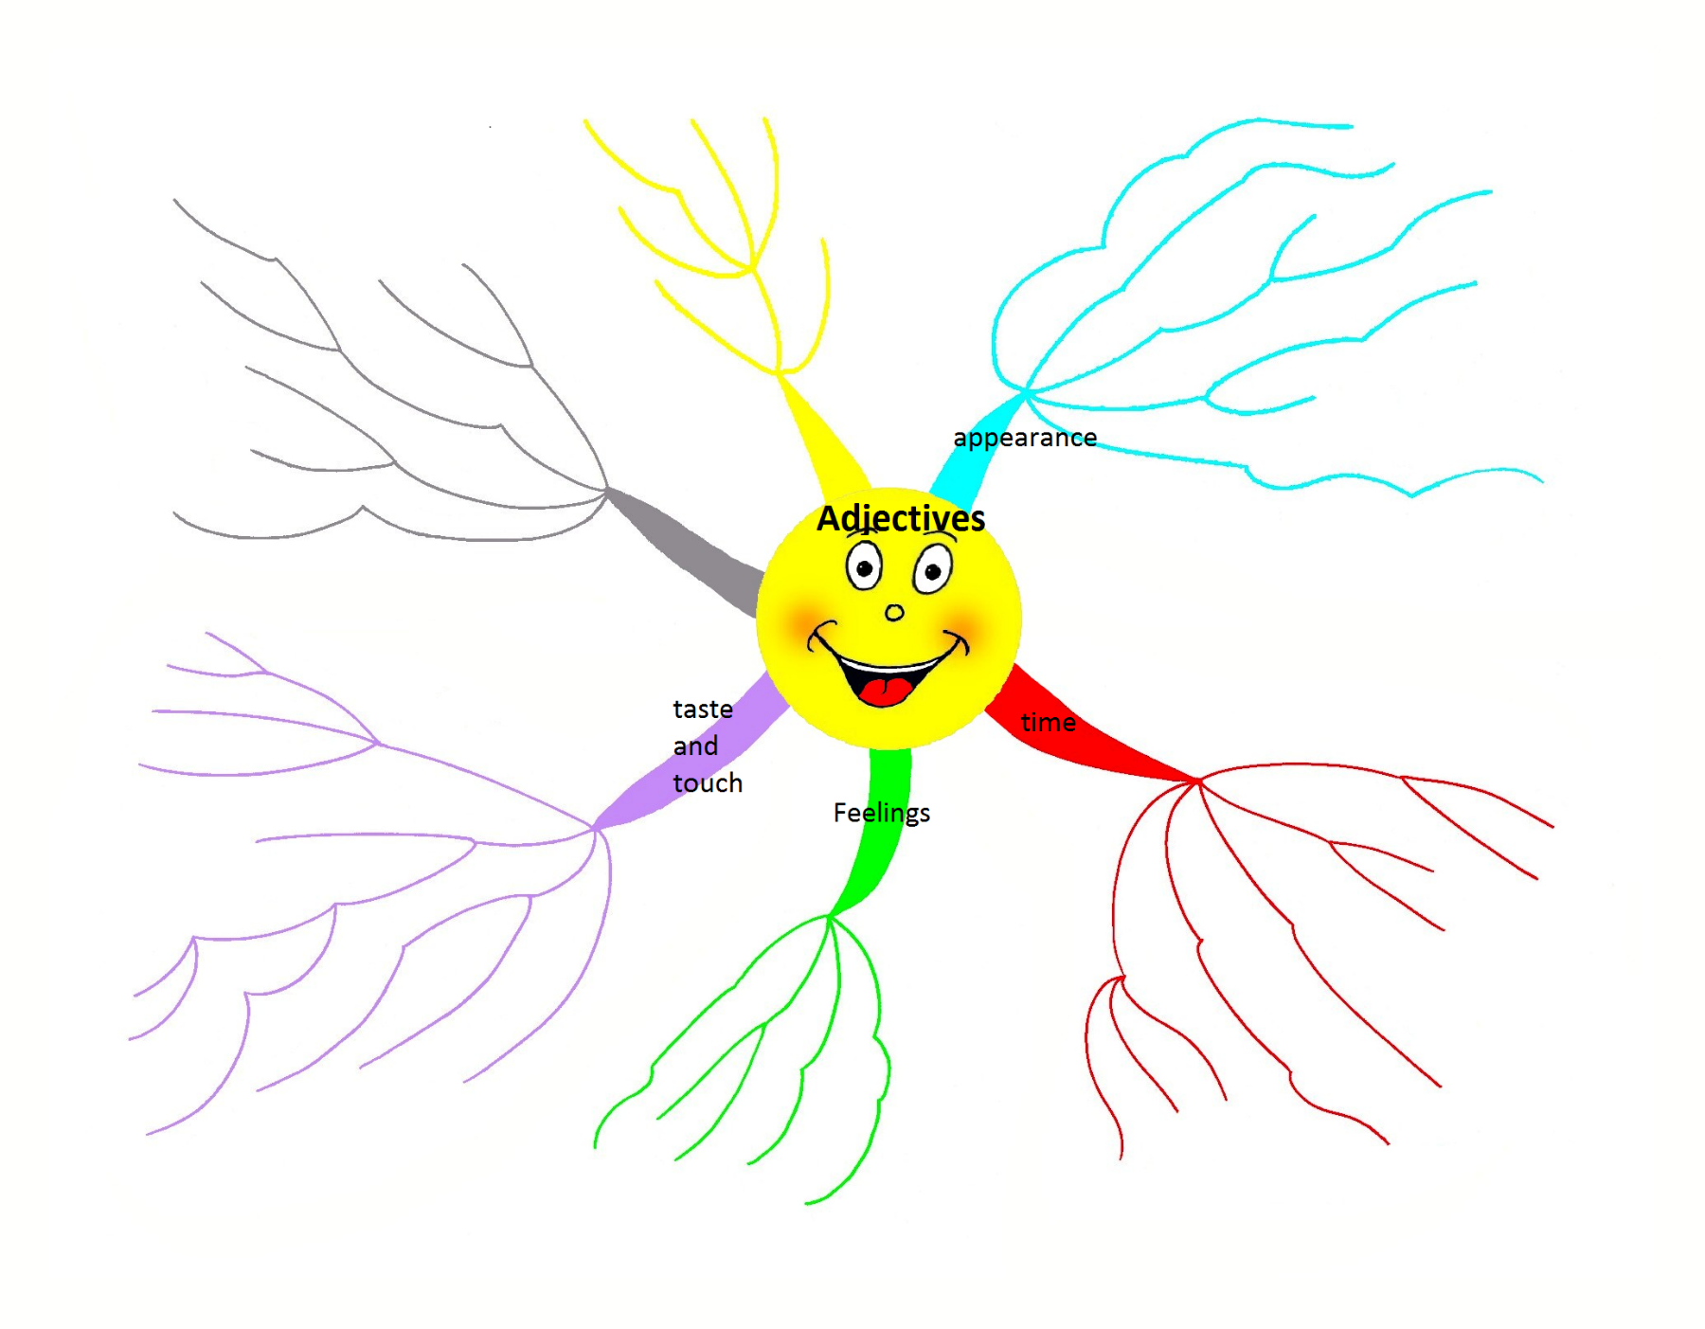**Activity 1: What do you already know?**

**Activity 2: (Adjective) Word Association**

|  |  |  |  |
| --- | --- | --- | --- |
|  |  |  |  |
| http://watermarked.cutcaster.com/901791452-Beautiful-girland-039-s-face.jpg | http://cache4.asset-cache.net/xc/158340086-naughty-boy-sticking-out-his-tongue-thinkstock.jpg?v=1&c=IWSAsset&k=2&d=B53F616F4B95E55371432481FEC3E0C7D7650006EB409819055CDD165A43E046BCC685C059D63657 | http://www.picgifs.com/clip-art/flowers-and-plants/flowers/clip-art-flowers-285113.jpg | http://nonakedwindows.com/Blog/wp-content/uploads/2013/08/11412-busy-multi-tasking-assistant-secretary-woman-typing-filing-organizing-and-taking-phone-calls-clipart-illustration.jpg |
|  |  |  |  |
| http://www.illustrationsof.com/royalty-free-waiting-clipart-illustration-434268.jpg | http://generic.pixmac.com/4/clever-sprite-mystery-surprise-picture-84086846.jpg | http://www.picturesof.net/_images_300/Black_and_White_Cartoon_Dad_Making_His_Son_Clean_His_Bedroom_Royalty_Free_Clipart_Picture_100209-170850-086042.jpg | https://encrypted-tbn3.gstatic.com/images?q=tbn:ANd9GcS66s0C9mUJ6xzrbbp9EohspM6sYdZrMF48lHLPrTwOrndqsl_m |

**Explanation: Understanding and Identifying Adjectives**

An **adjective** is a word that modifies a noun or a pronoun. It usually comes before the nouns it modifies. It can be a word, a phrase, or a clause.

Adjectives answer these five questions:

Which one? Example: I bought **that** coat.

Note: Only four adjectives answer this question: *this*, *that*, *these*, and *those*.

What kind (of)? Example: He likes **oatmeal** cookies.

How many? Example: **Two** boys tied for first place in the race.

How much? Example: Is there **enough** bread?

Whose? Example: **Linda’s** teacher e-mailed her about **her** essay.

**Activity 3: Identification**

Underline each adjective:

1. This old computer is worthless.
2. We haven’t heard a funny joke recently.
3. This windy weather leads to many fallen trees.
4. The wealthy ladies bought expensive jewelry in every store.
5. The frustrated, exhausted hunters walked on.
6. She is my favorite cousin.
7. The excited child ran along the busy sidewalk.
8. We sat in the first row of seats.
9. These two blue pens will not write.
10. Kelsey served English muffins for brunch.
11. Will you finish these chores, please?
12. Three large raccoons ate quickly at our empty campsite.
13. The petty thief entered stealthily.
14. The geologist drove that old truck to the dry lake bed.
15. The famous chef served Italian meatballs.
16. Shelly ate her cold pizza in the morning.
17. Do you like hot or mild peppers?
18. Edgar served French bread for lunch

**Game 1: The Rizla Game**

Listen to the instructions given you to by the teacher. Remember there are many ways you can play this game.

**Listening 1: Opposite Adjectives**

<http://www.learnamericanenglishonline.com/Red%20Level/R25_Opposite_Adjectives.html>

|  |  |  |  |  |  |  |
| --- | --- | --- | --- | --- | --- | --- |
| ADJECTIVE | YOUR ADJECTIVE |  | LISTENING | ADJECTIVE |  |  |
| asleep |  |  | healthy |  |  |
| alert |  |  | hungry |  |  |
| alive |  |  | interesting |  |  |
| awesome |  |  | left |  |  |
| best |  |  | loose |  |  |
| big |  |  | loud |  |  |
| bitter |  |  | low |  |  |
| brave |  |  | narrow |  |  |
| bright |  |  | normal |  |  |
| calm |  |  | old |  |  |
| certain |  |  | on |  |  |
| close |  |  | open |  |  |
| cold |  |  | public |  |  |
| cool |  |  | raw |  |  |
| complete |  |  | regular |  |  |
| cruel |  |  | right |  |  |
| dark |  |  | rough |  |  |
| dangerous |  |  | short |  |  |
| different |  |  | small |  |  |
| dirty |  |  | smart |  |  |
| dry |  |  | soft |  |  |
| early |  |  | special |  |  |
| easy |  |  | straight |  |  |
| far |  |  | tender |  |  |
| fast |  |  | top |  |  |
| fat |  |  | true |  |  |
| future |  |  | white |  |  |
| happy |  |  | wise |  |  |

**Order of Adjectives:**

As you have seen before, if you use more than one adjective at a time you have to put them in order:

**Opinion Size Age Shape Colour Origin Material Purpose *Noun***

|  |  |  |  |  |  |  |  |  |
| --- | --- | --- | --- | --- | --- | --- | --- | --- |
| crazy |  | old |  |  | American |  |  | *woman* |
|  |  |  | round | white |  | china |  | *plate* |
|  | big |  |  |  |  |  | craving | *knife* |

**Practice 1:**

Rewrite the sentences putting the adjectives in the correct order.

Example: He wore a shirt. (blue, denim, stylish)

________He wore a stylish, blue, denim shirt._____________________________________

1. The shop assistant put the gift into a bag. (brown, small, paper)

_________________________________________________________________________

1. They're showing a movie at the cinema tonight. Do you want to go? (action, new)

_________________________________________________________________________

1. I’m going to a party tonight. I bought a dress to wear. (sexy, white, short)

_________________________________________________________________________

1. The man ran down a street to the police station. (long, narrow)

_________________________________________________________________________

1. Paul sang a song to his girlfriend. (slow, love)

_________________________________________________________________________

1. It was so nice to come in from the cold and eat a meal. (hot, delicious)

_________________________________________________________________________

1. She was a beautiful lady with blonde hair. (curly, long, lovely)

_________________________________________________________________________

1. I just bought a sports car. (German, black, new)

_________________________________________________________________________

1. Watch out! There is a dog over there. (black, ferocious, big)

_________________________________________________________________________

10. Do you want to play badminton? It’s a sunny day outside. (lovely, bright)

_________________________________________________________________________

**Activity 4: Simple Text**

It is a day in November. There is a boy playing in the woods. He is playing with a friend. They are playing with sticks. They are playing a game. They hear a noise. They go and investigate what the sound is. They find out it is….

**Activity 5: Story Time**

Using all the descriptions we have learnt so far write a short story. Your story can be about anything you like, just make it interesting. Here are some tips:

* Try and use as many adjectives as you can
* Remember to pay attention to tenses

Here are some ideas for stories:

* You are stranded on an island. How did you get there? How will you get home?
* You went for a walk one day and got lost. Where are you? How will you get home? What did you see?
* You play for a sports team and you are in the final of the league. Tell the story of the final. Do you win?
* Retell a famous Colombian story, in English…