Tuesday October 22, 2013
Grammar Presentation of possessive adjectives and possessive pronouns:

Possessive Adjectives | Possessive Pronouns
my  your  his/her/its  our  their | mine  yours  his/hers  ours  theirs
Uses | Uses
1. Use with nouns or noun phrases. For example:  - What’s his problem?  - Jill doesn’t have our phone number.  - It is his car. | 1. Use them alone, not with nouns or noun phrases. For example:  - Everyone has problems. What’s his?  - Joe has everyone’s number apart from mine  - ‘Who’s car is that?’  It is mine.
Adjectives are describing words that you use to describe nouns | Pronouns are words that we use instead of nouns

Special notes:
- Adjectives are not plural in English so possessives only have one form. For example:
That is my key That is our key That is their key
Those are my keys Those are our keys Those are their keys
- There is not commonly used possessive pronoun for it. You have to use the original noun.and the possessive adjective instead.

- Do not get confused between its and it’s:
its = possessive adjective
it’s = contraction for it is or it has

Gap fill
Ex: 1 Whose video is this? Is it ..yours. ? (you)
Ex: 2 Excuse me, those are ,.our.. seats, (we)
3 Is it _____________________bag or ______________________? (you/he)
4 Has the cat had ________________________ food? (it)
5 They're not _____________________ keys , they're ________________________________ (I/she)
6 I don't think its ___________________________ room: I think it's ___________________________ (you/they)
7 The police asked me for ________________________________ address. (I)
8 Have you got _______________________ pencil, or would you like to borrow_________________? (you/I)
9 ____________________________ house is larger than __________________________ (they/we)
10 I think this is _________________________ CD. Oh no, it's _________________________ (I/you)
11 The decision is all _____________________________________ (they)
12 The rabbit wants __________________________________ breakfast. (it)
13 You know it's not _____________________________ food. It's ________________________________ (you/I)
14 It isn't ________________________________ motorbike, it's _______________________________ (he/she)
15 It wasn't _______________ mistake, it was ______________ for getting the food order wrong. (I/they)
16 Have you met ______________________________ sister, Sarah? (they)
17 _____________________________ mum and dad say the decision is __________________________ (she/they)
18 ____________________________ brother hasn't got a phone, so he uses __________________________ (I/we)
19 ____________________ car wasn't working, so I used ______________ motorbike to get to work (I/he)
20 _______________________ flat is smaller than ____________________________ (we/they)

Other resources:
Online games to practice: http://www.eslgamesplus.com/possessive-adjectives-game/
Youtube explanation: http://www.youtube.com/watch?v=XdkQNkIL6uc

Possessives using apostrophes:

The apostrophe is used to donate the possession of the noun that the -‘s- is added to:
The dog’s bone. (The bone is the possession of the dog.)
*You can only use an apostrophe with a noun—not with a pronoun!

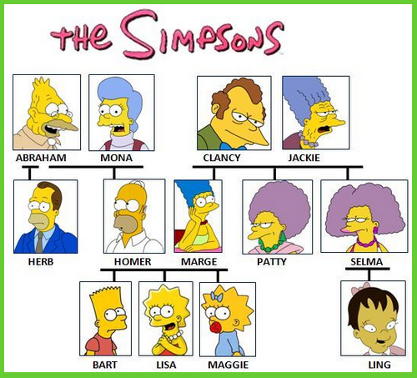 The

- Bart is Lisa's …………………….
- Marge is Homer's .…………………….
- Clancy is Selma's .…………………….
- Maggie is Ling's ……………………..
- Lisa is Patty's ……………………..
- Homer is Abraham's ……………………..
- Selma is Ling's adoptive ……………………..
- Bart is Herb's ……………………..
- Maggie is Marge's ……………………..
- Herb is Marge's ……………………..
- Patty is Selma's ……………………..
- Herb is Homer's ……………………..
- Abraham is Marge's ……………………..
- Herb is Maggie's ……………………..
- Jackie is Homer's ……………………..
- Marge is Herb's……………………..
- Homer and Marge are Lisa's ……………………..
- Homer is Clancy's ……………………..
- Bart and Lisa are Maggie's ……………………..
- Abraham is Lisa's …………………….

Songs #1: Five People (Sesame Street):
http://www.youtube.com/watch?v=dQ8zgWfkLQE
Lyrics:
Oh I’ve got five people in my family. And there’s not one of them I’d swap.
There is a sister, and two brothers, and a mother, and a pop (that’s me!).
Oh five is such a pretty number, I’m awfully glad that I’ve…five people in my family.
1, 2, 3, 4, 5. One, two, three, four, fiiiiive.

Song #2: Finger Family:
http://www.youtube.com/watch?v=mjFcrv6Lfx8
Lyrics:
Daddy finger, daddy finger, where are you? Here I am, here I am, how do you do?
(Mommy finger…brother finger….sister finger…baby finger)

Family Vocab List:
Mom/mommy/mother | Madre | Niece | Sobrino
Dad /daddy/ father | Padre | Nephew | Sobrina
Son | Hijo | Half brother/half-sister | Medio hermano/a
Daughter | Hija | Parent(s) | Padre(s)
Brother | Hermano | Husband | Esposo/marido
Sister | Hermana | Wife | Esposa
Grandfather | Abuelo | Godmother | Madrina
Grandmother | Abuela | Godfather | Padrino
Grandson | Nieto | Godchild | Ahijado
Granddaughter | Nieta | Father-in-law | Suegro
Grandchild/grandchildren | Nieto(s) | Mother-in-law | Suegra
Uncle | Tío | Stepbrother/stepsister | Hermanastro/a
Aunt | Tía | Fiancé/fiancée | Prometido/a
Cousin | Primo/a | Groom | Novio
Twin | Gemelo/a | Bride | Novia
Great grandmother | Bisabuela | Great grandfather | Bisabuelo

The Story of Goldilocks and the Three Bears
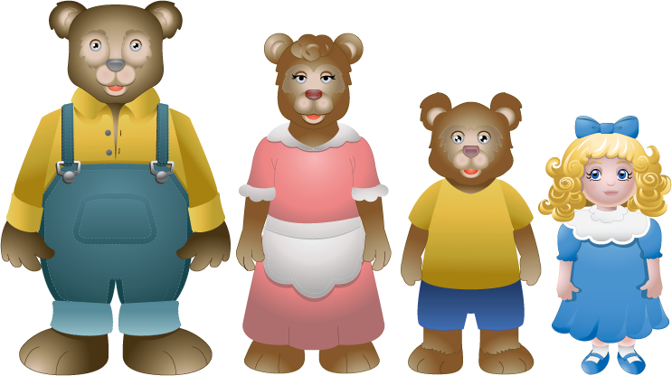
Once upon a time, there was a little girl named Goldilocks. She went for a walk in the forest. Pretty soon, she came upon a house. She knocked and, when no one answered, she walked right in. At the table in the kitchen, there were three bowls of porridge. Goldilocks was hungry. She tasted the porridge from the first bowl.
"This porridge is too hot!" she exclaimed.
So, she tasted the porridge from the second bowl.
"This porridge is too cold," she said
So, she tasted the last bowl of porridge.
"Ahhh, this porridge is just right," she said happily and she ate it all up.
After she'd eaten the three bears' breakfasts she decided she was feeling a little tired. So, she walked into the living room where she saw three chairs. Goldilocks sat in the first chair to rest her feet.
"This chair is too big!" she exclaimed.
So she sat in the second chair.
"This chair is too big, too!" she whined.
So she tried the last and smallest chair.
"Ahhh, this chair is just right," she sighed. But just as she settled down into the chair to rest, it broke into pieces!
Goldilocks was very tired by this time, so she went upstairs to the bedroom. She lay down in the first bed, but it was too hard. Then she lay in the second bed, but it was too soft. Then she lay down in the third bed and it was just right. Goldilocks fell asleep. As she was sleeping, the three bears came home.
"Someone's been eating my porridge," growled the Papa bear.
"Someone's been eating my porridge," said the Mama bear.
"Someone's been eating my porridge and they ate it all up!" cried the Baby bear.
"Someone's been sitting in my chair," growled the Papa bear.
"Someone's been sitting in my chair," said the Mama bear.
"Someone's been sitting in my chair and they've broken it all to pieces," cried the Baby bear. They decided to look around some more and when they got upstairs to the bedroom, Papa bear growled, "Someone's been sleeping in my bed,"
"Someone's been sleeping in my bed, too" said the Mama bear
"Someone's been sleeping in my bed and she's still there!" exclaimed Baby bear. Just then, Goldilocks woke up and saw the three bears. She screamed, "Help!" And she jumped up and ran out of the room. Goldilocks ran down the stairs, opened the door, and ran away into the forest. And she never returned to the home of the three bears.

Reading Comprehension Questions
- Who are the characters in this story?
- Whose porridge was too hot?
- Which chair did Goldilocks like best?
- How did the bears feel when they got home?
- Write three sentences using the correct possessive adjectives or pronouns to describe the Mama Bear’s, Papa bear’s and Baby bear’s porridge, chairs and beds.

