Week 10: Tuesday November 19, 2013

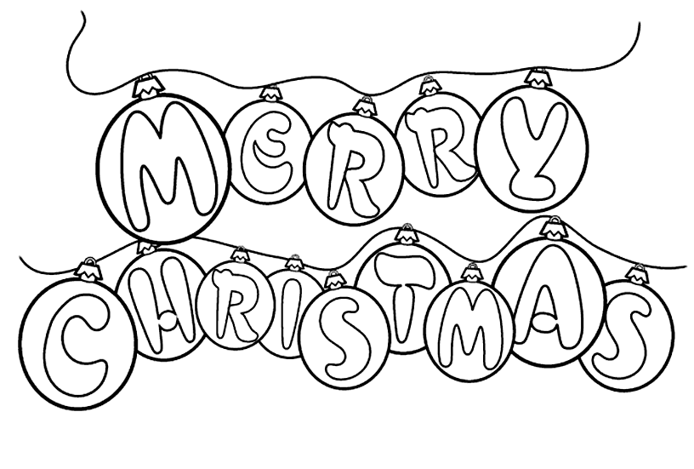
Christmas Vocabulary:
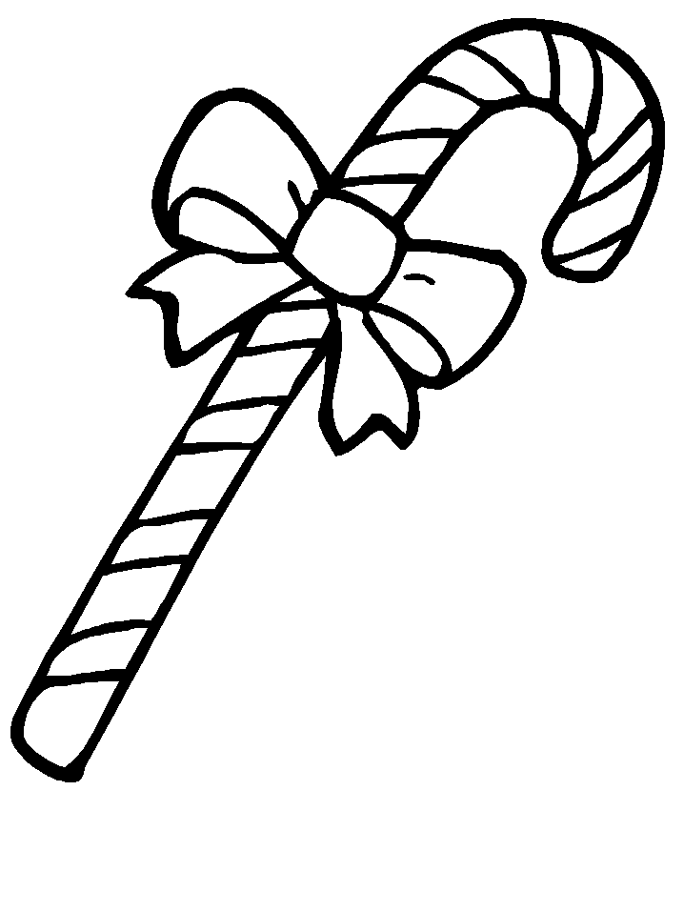
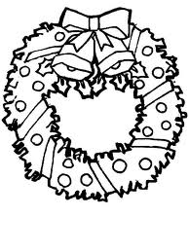
Angel | Caroling | Cookies
Baby Jesus | Chimney | Mistletoe
Bells | Christ | North Pole
Candy cane | Gingerbread house / man | Nutcracker
Carolers | Father Christmas | Reindeer
Gift | Fireplace | Saint Nicholas  /St. Nick
Santa's elves | Santa’s helpers | Santa's workshop
Santa’s list | snow | unwrap
Manger | Naughty | Nice
Snowman | Stocking | Sleigh
Christmas card | Caroling/ carols | Charity
Holly | Holiday
Christmas Eve | Eggnog | Cider
Coal | December 25 | Joy
Christmas tree | Christmas decorations | Santa Claus
Ornaments | Presents | Wreath
Toy | Bethlehem | Nativity scene

Children’s Christmas Songs:
Rudolph the red-nosed reindeer
http://www. youtube.com/watch?v=tQpP9Ippfps
Frosty the snowman
http://www.youtube.com/watch?v=k6zW225k_O0
Jingle Bells
http://www.youtube.com/watch?v=v7s2VjwQSMw
We Wish you a merry Xmas
http://www.youtube.com/watch?v=yYgFcgpM9Kg
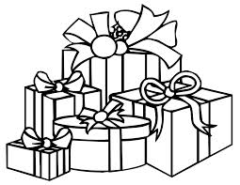
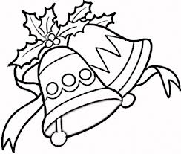
Santa Claus is coming to town http://www.youtube.com/watch?v=HWv72L4wgCc

