Wednesday, June 19, 2013
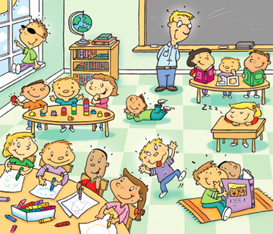

Etiqueta los siguientes objetos en la imagen: -Book -Table -Chair -Chalk -Eraser -Board -Window -Marker -Toys -Paper
Agrega los siguientes objetos a la imagen: -Pencil -Door -Clay -Glue
-Colored Pencils -scissors
Proyecto: Crear una clase con todos los objetos necesarios, con los objetos etiquetados con los nombres apropiados
Games and Activities: Take out/Touch the classroom object
Connect a verb with an action
I spy with verbs; “I spy something that draws”

Future tense
In English, there are two types of future tense. One is formed by adding the word ‘will,’ the other by using the form ‘going to.'

 | WILL + infinitive | BE GOING TO + infinitive
Intention | (decided at the time of speaking; spontaneous offers, promises, decisions)  Come on, I´ll help you will those bags  I will always love you | (decided before the time of speaking, but not yet fully planned)  I am going to clean my house on Saturday  We´re going to get married
Prediction | (Based on personal judgment, opinion or intuition)  I think you´ll find this interesting  If you ask him, he will probably give you a ride. | (based on present evidence; the predicted event is very near or is surely going to happen)  My sister is going to have a baby in May  Look at the clouds, it´s going to rain.

Fill in the blank with the correct form of the future tense.
- Why are you holding a piece of paper? I (write) ____________ a letter to my friend in Texas
- I´m about to fall asleep, I need to wake up! I (get) _______________ you a cup of coffee
- I can´t hear the television! I (turn) __________ it up for you so you can hear it
- We are so excited for our trip next month to France. We (visit) __________________ Paris, Nice and Grenoble
- It´s so hot in here! I (turn) _______________ on the air conditioning
- After graduating, I (attend) ___________________ medical school. I have wanted to be a doctor my whole life.
- If you eat all your dinner, I (give) __________ you dessert.
- I can´t believe they (go) ______________ the Madonna concert!
- I (buy) __________________ lunch, do you want anything?
- Who do you think (win) ______________ the election?
To form a question: invert the subject and the auxiliary verb (will/be)
He will buy a car tomorrow Will he buy a car tomorrow?
She is going to make dinner Is she going to make dinner?
You are going to a concert in June Are you going to a concert in June?
To use form the future in the negative, put “not” after the auxiliary verb (will + not = won’t)
They will visit me in the hospital They will not (won’t) visit me in the hospital
I am going to change my name I am not going to change my name

Pair and Share: What will you do during vacation?
Find Someone Who
Songs to practice future tense:
You’ll always be my baby by Mariah Carey
It will Rain by Bruno Mars
Hope of Deliverance by Paul McCartney
Wherever you will go by The Calling

